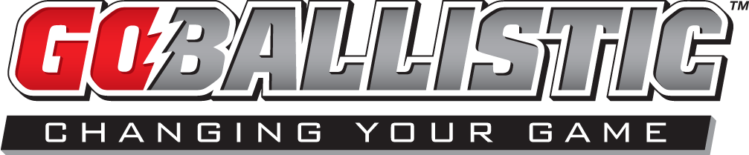

www.goballisticsports.com 201-412-2832 goballisticsports@gmail.com

Why should my team use GoBallistic?
GoBallistic Sports offers a turn-key solution for schools, organizations, teams and clubs looking to up-level their look with custom designed uniforms, team apparel, gear, spirit wear and much more.

What is a “sublimated” uniform?
The dye-sublimation printing process is used to print on synthetic fabrics, like moisture-wicking sports apparel. Images are initially printed on coated heat-resistant transfer paper as a reverse image of the final design, which is then transferred onto fabric in a heat press operating at a temperature around 375º F. Under high temperature and pressure, the dye turns into a gas and permeates the fabric and then solidifies into its fibers. The fabric is permanently dyed so it can be washed without damaging the quality of the image.
What are the advantages of sublimation over other methods of textile printing?
- You will have a uniform that is unique to you – no off-the-shelf designs that every other team uses
- Images are permanent and do not peel or fade
- Colors can be extraordinarily brilliant
- Truly continuous tones can be achieved
- The image can be printed all over the entire item
- We use a lightweight moisture-wicking material
So if you take care of your uniform, it will look good for the entire season, or longer.

Does GoBallistic just do sublimated uniforms?
We offer both sublimated and off-the-shelf options so there’s always something for every team and budget.

Does GoBallistic just do lacrosse and basketball uniforms?
We can do it all…baseball, track & field, field hockey, soccer and more! In addition, we offer youth, adult and ladies sizing.

How much are the uniforms?
Our uniform prices are in line, or less expensive than other retailers’ prices. Of course, costs vary depending on the complexity of the design, quantities ordered and how much customization is involved. Call us at 201-412-2832 and we can give you a quote.

How do I pay?
This varies by client and type of project we are working on for you. We accept credit cards and checks for uniform accounts and have an online store for spirit wear sales that accepts credit cards.
v09.17.14
What is the turn-around time for a custom, sublimated uniform?
Once your final design has been approved, a minimum of three weeks is required for production of the uniforms. In addition to production time, you should factor in up to 10-days for the design phase which will vary (more or less) depending on the complexity of the design and client feedback/approval.

Why are the prices different in the other online stores?
Every team/school has a different need and/or objective and our pricing is reflective of those objectives. For example, some schools set higher fundraising goals, some want to keep their items more affordable. In addition, the cost of a particular item varies based on number of colors, complexity of the logo, number of logo placements, actual item selected, etc. Rest assured, we guarantee quality apparel at great prices.

What is your return policy?
Since each uniform is custom designed specifically for your team, we have a no return policy after your order has been placed. We have size runs of uniforms and sizing guides to ensure a perfect fit for everyone on the team. As it relates to team gear and spirit wear, items cannot be returned unless there is a manufacturer’s defect, in which case we will be happy to exchange the product or refund your money.

Can I get names on the uniforms?
Of course! The addition of names on uniforms carries a slight upcharge, but can certainly be done.

Can I supply my own graphics for a uniform?
Sure. We prefer that all art be supplied in Adobe Illustrator format for the best results. But we can also use Adobe Photoshop files at 300 dpi — at actual size. All fonts should be converted to outline and any placed images should be supplied as separate files.

v09.17.14

www.goballisticsports.com 201-412-2832 goballisticsports@gmail.com

